*Project title* **:Real time river water quality management and control system.**

**Project Design Phase -I**

Problem -solution fit

**Team ID:** PNT2022TMID41871

**Explore AS, differentiate**

**Deﬁne CS, ﬁt into CC**

or need to get the job done? What have they tried in the past? What pros & cons do these solutions have ?

Quality checking field officer will get samples physically and these samples are sent to laboratory for testing

Pros: Results will be accurate

Cons: It will more time for implemention and the process will take huge time

**AS**

**5. AVAILABLE SOLUTIONS**

Which solutions are available to the customers when they face the problem

What constraints prevent your customers from taking action or limit their choices

of solutions?

*High investment needed for initial installation

*Less awareness in people about it’s applications

*Network issues in under developed areas

**CC**

**6. CUSTOMER CONSTRAINTS**

**CS**

**1. CUSTOMER SEGMENT(S)**

Who is your customer?

Government employee

**Explore AS, differentiate**

**Define CS, fit into CC**

**Identify strong TR & EM**

Used water filters for filtration of water for drinking purpose.

Tried to complaint about water quality in municipal corporation

**BE**

**7. BEHAVIOUR**

What does your customer do to address the problem and get the job done?

**RC**

**9. PROBLEM ROOT CAUSE**

What is the real reason that this problem exists? What is the back story behind the need to do this job?

The main cause of this problem is due to disposal of wastes int river water which is leading to water pollution.

**J&P**

**2. JOBS-TO-BE-DONE / PROBLEMS**

Which jobs-to-be-done (or problems) do you address for your customers? There could be more than one; explore different sides.

To design a system using IOT for controlling and monitoring of river water quality and produce real-time information

**Focus on J&P, tap into BE, understand RC**

**Focus on J&P, tap into BE, understand RC**

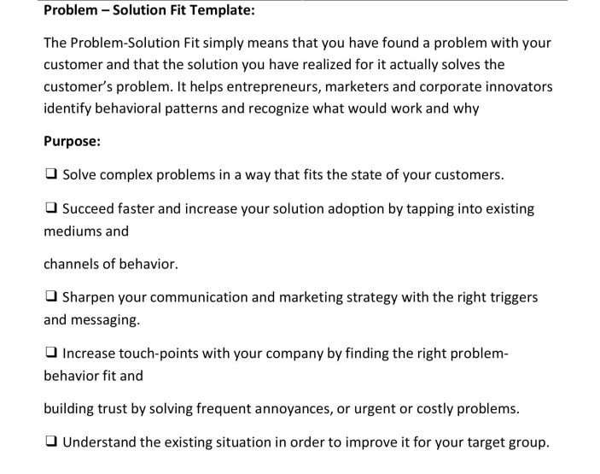

**Identify strong TR & EM**